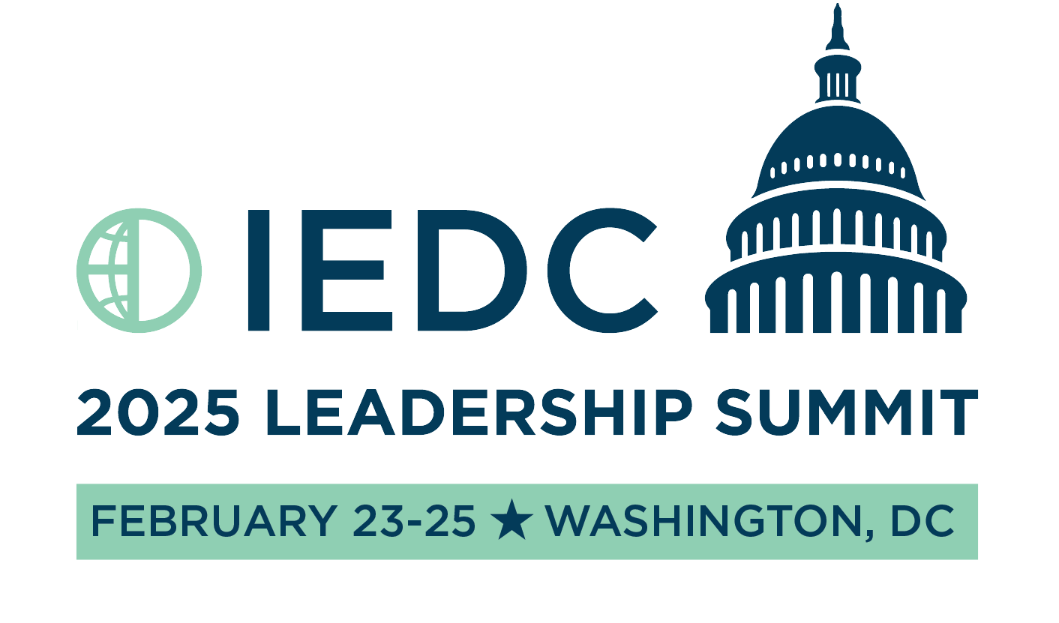

Re: Request for Approval to Attend the 2025 IEDC Leadership Summit

Dear [Supervisor’s Name],

I am writing to request approval to attend the 2025 IEDC Leadership Summit, taking place on February 23 – 25, 2025 in Washington, DC. As the role of economic developers continues to evolve in response to new trends, this summit provides a critical opportunity for professional development that will directly benefit [Your Organization].

The IEDC Leadership Summit is specifically designed for economic development professionals at all career stages, offering tailored tracks for emerging leaders, mid-level professionals, C-suite executives, minority leaders, and women leaders. Given the increasing importance of technological innovation, sustainability, equity, and policy engagement, this summit will provide key insights and tools that are essential for staying competitive in today’s complex landscape.

By attending the Leadership Summit, I will be able to:

* **Enhance Leadership Skills:** Through the summit’s leadership-focused tracks, I will gain insights on visionary leadership, strategic planning, and effective team management that can be applied to improve our internal processes and initiatives.
* **Acquire the Latest Knowledge:** Participate in sessions that cover current economic development trends, from leveraging AI and automation to integrating climate resilience and inclusive growth into our strategies.
* **Build Strategic Relationships:** Connect with industry peers, potential collaborators, and thought leaders in the economic development community, which will strengthen our network and open doors for new partnerships.
* **Bring Back Actionable Takeaways**: Upon my return, I will organize a debriefing session to share the key insights and actionable strategies with our team, ensuring that the entire organization benefits from this experience.

**Estimated Costs:**

Registration: $[Amount]

Transportation: $[Estimated]

Hotel Accommodations: $[Amount]

Meals and Incidentals: $[Estimated]

Total Investment: $[Estimated]

Taking advantage of Early Bird registration by January 31st will reduce the cost, providing a savings opportunity for the organization.

Given the rapid changes in our field, it is essential that we stay ahead of these shifts and equip ourselves with the necessary tools to drive growth and resilience. The insights and professional connections I will gain from this summit will significantly contribute to our ongoing projects and long-term goals.

I am happy to discuss this opportunity further and address any questions you may have. Thank you for considering my request.

Best regards,  
[Your Name]  
[Your Position]